**LDB Loftware Print Server**

**Version 1.0**

**Configuration Guide**

The purpose of this document is to provide step by step instruction on configuring Loftware server for Label printing from Tecsys WMS application.

**Loftware Device setup**

* Open Design32 from the Start menu under Loftware Labeling.
* Press **F6** to open LLM Device Connections

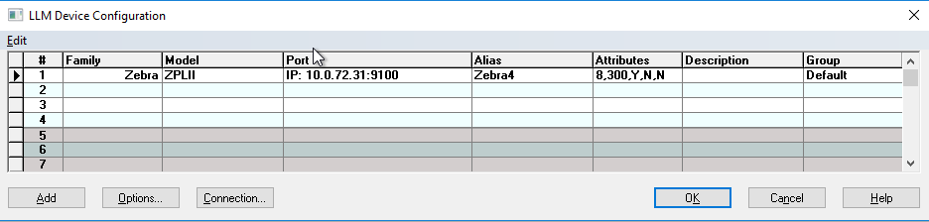

* Click **Add** to add new printer device.

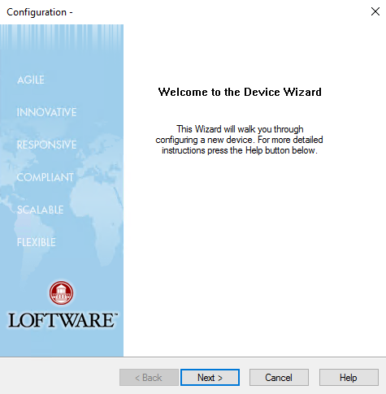

* Click **Next**

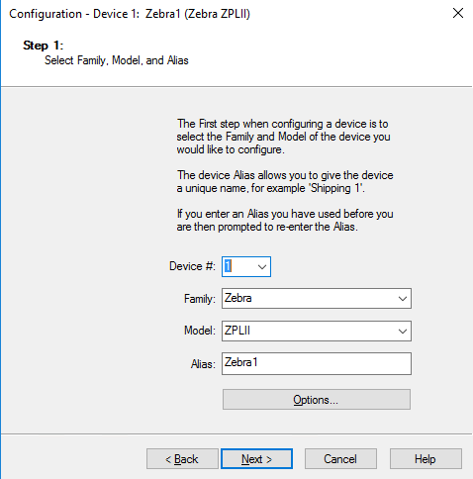

* Select Family: Zebra and Model: ZPLII and Alias Zebra1
* Click **Next**

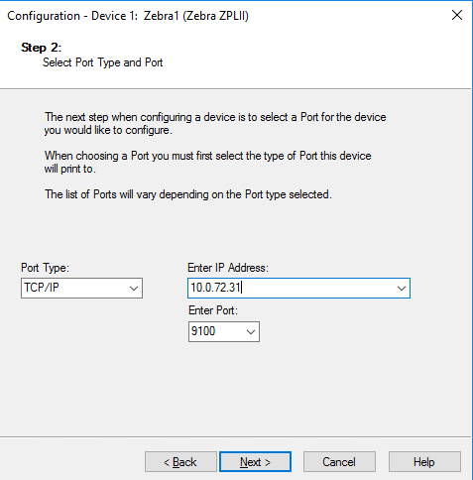

* Select Port Type TCP/IP and enter IP Address 10.0.72.31 and Port 9100
* Click **Next**

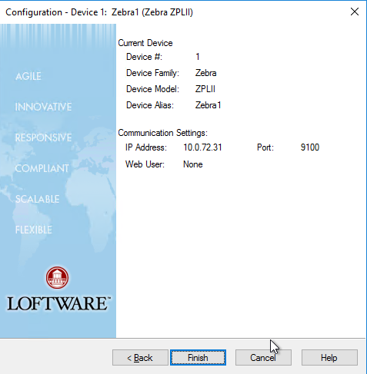

* Click **Finish**



* Click **OK**

**Start Printer Service**

* Launch Loftware Printer Server Configuration Utility

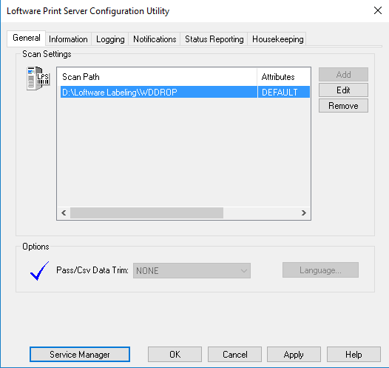

* Click **Service Manager**

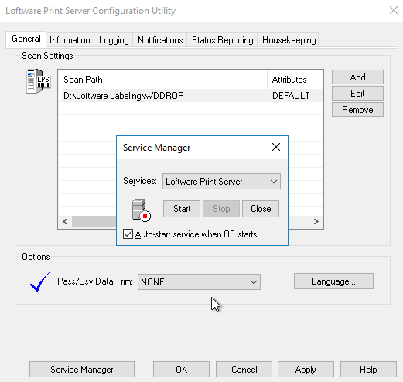

* Click **Start**

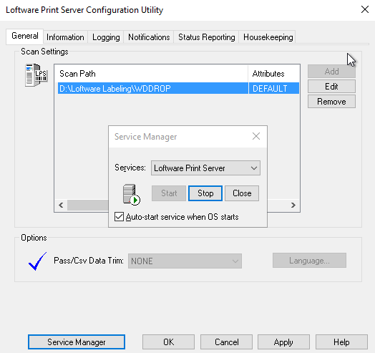

* Click **Close** > **Apply** > **OK**

**Enable Port Listener**

* Launch the DSIConfig.exe application in the Loftware Labeling directory.
* On the LPS Direct Socket Interface Configuration dialog, select Enable Direct Socket Interface.

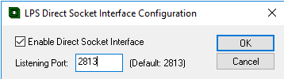

* Leave the Listening Port set to 2813.
* Click **OK** to accept the settings
* Restart Loftware Print Service.

Verify port 2813 listening using window command **netstat –ab | findstr 2813**

cid:image003.png@01D3D7CE.A5CC97C0

**Tecsys output device setup**

* Open Tecsys > goto output device view
* Add device as below.

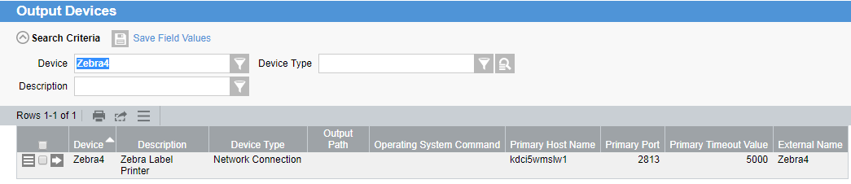

**Label deployment**

On Loftware server checkout labels from SVN repository

<http://subversion.bcliquor.com/svn/WMS/Reports/LoftwareLabels/trunk>

to folder **D:\Loftware Labeling\LABELS**